**Design principles & Patterns**

**Exercise 1: Implementing the Singleton Pattern**

Name:SingletonPatternExample

**Code:**public class Logger {

    private static volatile Logger instance;

    private Logger() {

     System.out.println("Logger Initialised");

    }

    public static Logger getInstance(){

    if(instance==null){

        synchronized(Logger.class){

            if(instance==null){

                instance = new Logger();

            }

        }

    }

    return instance;

}

   public void log(String message) {

        System.out.println("Log:" + message);

}

}

**Output :**

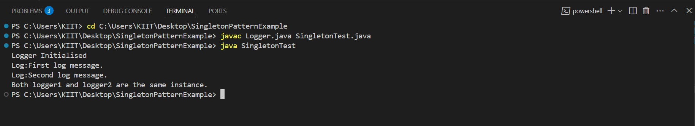

**Exercise 2: Implementing the Factory Method Pattern**

Name:FactoryMethodPatternExample

**Code:**

// Document

public interface Document {

    void open();

}

// WordDocument

public class WordDocument implements Document {

    public void open() {

        System.out.println("Opening a Word document.");

    }

}

// PdfDocument

public class PdfDocument implements Document {

    public void open() {

        System.out.println("Opening a PDF document.");

    }

}

// ExcelDocument

public class ExcelDocument implements Document {

    public void open() {

        System.out.println("Opening an Excel document.");

    }

}

// DocumentFactory

public abstract class DocumentFactory {

    public abstract Document createDocument();

}

// WordDocumentFactory

public class WordDocumentFactory extends DocumentFactory {

    public Document createDocument() {

        return new WordDocument();

    }

}

// PdfDocumentFactory

public class PdfDocumentFactory extends DocumentFactory {

    public Document createDocument() {

        return new PdfDocument();

    }

}

// ExcelDocumentFactory

public class ExcelDocumentFactory extends DocumentFactory {

    public Document createDocument() {

        return new ExcelDocument();

    }

}

// FactoryTest

public class FactoryTest {

    public static void main(String[] args) {

        DocumentFactory wordFactory = new WordDocumentFactory();

        Document wordDoc = wordFactory.createDocument();

        wordDoc.open();

        DocumentFactory pdfFactory = new PdfDocumentFactory();

        Document pdfDoc = pdfFactory.createDocument();

        pdfDoc.open();

        DocumentFactory excelFactory = new ExcelDocumentFactory();

        Document excelDoc = excelFactory.createDocument();

        excelDoc.open();

    }

}

**Output:**

